ANSIBLE ROLES AND VARIABLES

Pre-setup:

Create your own directory(ansible) and copy the ansible.cfg, hosts, roles from root



Keep your file.csv in ansible directory



ROLES:

The first step in creating a role is creating its directory structure. To create the base directory structure, going to use a tool bundled with Ansible called ansible-galaxy:

Go to roles directory and create role “servicenow”



ansible-galaxy init servicenow

That command will give servicenow directory with the following structure

├── README.md

├── defaults

│ └── main.yml

├── files

├── handlers

│ └── main.yml

├── meta

│ └── main.yml

├── tasks

│ └── main.yml

├── templates

└── vars

__main.yml

So place your playbook under tasks and place your sensitive variables to variables directory.

Variables:

It can be re-usable and can separated from the playbook.

1.Go to the directory and create yaml file which calls the role



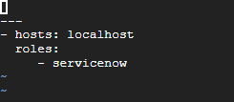

2. And then go to variable section and open main.yml for adding variables

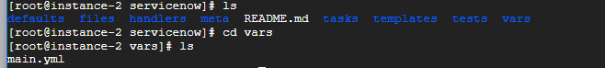

Open main.yml under variable section and then add your snow credentials and instance details

**---**

**snow_username : admin**

**Snow_password : XXXXX**

**Snow_instance : dev71301**

Using Ansible-Valut Encrypting unencrypted files

Please use the below command to encrypt under var directory which has main.yml

ansible-vault encrypt main.yml

Run the above command and set the vault password **ansible99**

Now you can see it is encrypted below and the credentials wont be visible

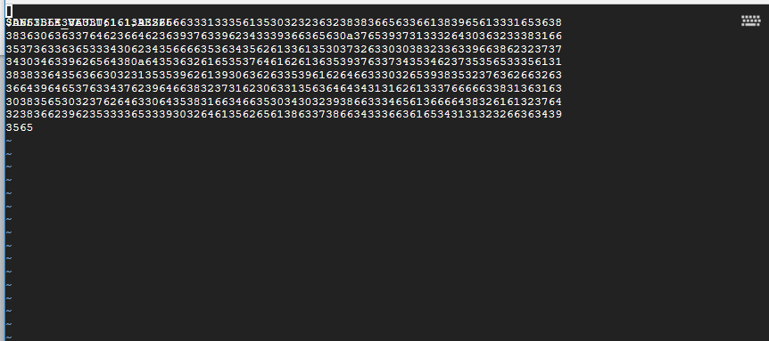

If you want to view the sensitive variable which mention in vault, please use below command

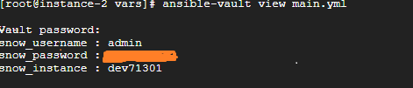

And then go to tasks directory and write our playbook in main.yml



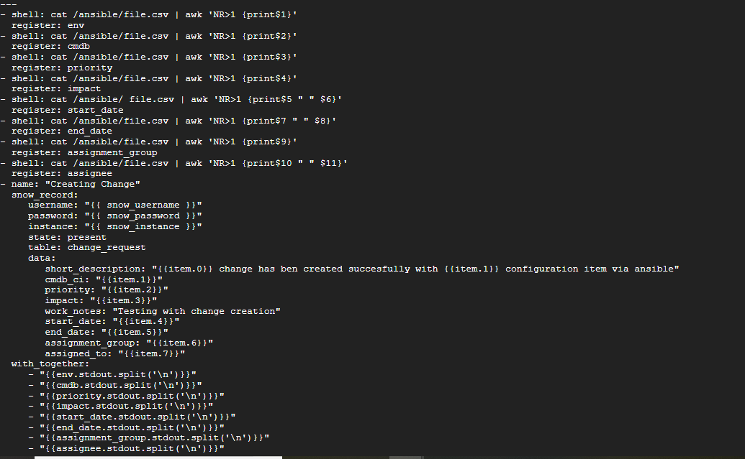

In ansible.cfg mention the path of role and host

Inventory = /root/ansible/hosts

roles_path = /root/ansible/roles

Run the playbook

**ansible-playbook changecreation.yml --ask-vault-pass**

It will ask the password, please provide the below password

Password: ansible99

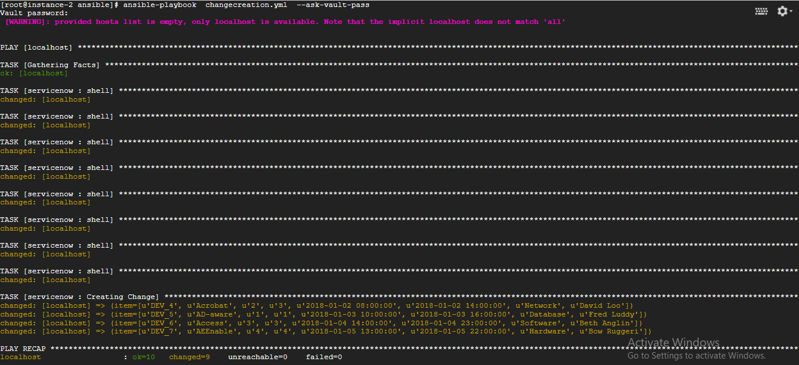

**4 changes created in snow**

